Steps and procedure to run the Connector along with Simulator

Mobile App (BLE Serial Monitor) – Usage Steps
- Install the BLE Serial Monitor mobile application.
- Open the app and click on the menu list. You will see the name Devices, click on it.
- Select Bluetooth LE, then click on Scan.
  - You should find “NitaraCLV4” in the scanned device list.
  - If the device is not visible, it indicates that the firmware may not be loaded properly or the device is malfunctioning.
- Select NitaraCLV4. The terminal screen will appear.
- On the right side of the terminal, click on the Connect icon.
  - The status should change to Connected.
- Send the MA configuration command to the board.
  - After sending the command, you should receive a success response.
- After successful configuration, proceed to run the simulator.
Example MA Configuration Command:
{"command":"ma_port_config","model":1002,"baud_rate":1200,"data_bits":8,"stop_bits":1,"parity":0,"stream":0}#
Note:
- The model and baud rate must match the simulator settings.

Steps to Run the Connector Using the Simulator
- Connect the DB9 connector cable to the MA_IN port of the connector and connect the USB cable to the laptop. 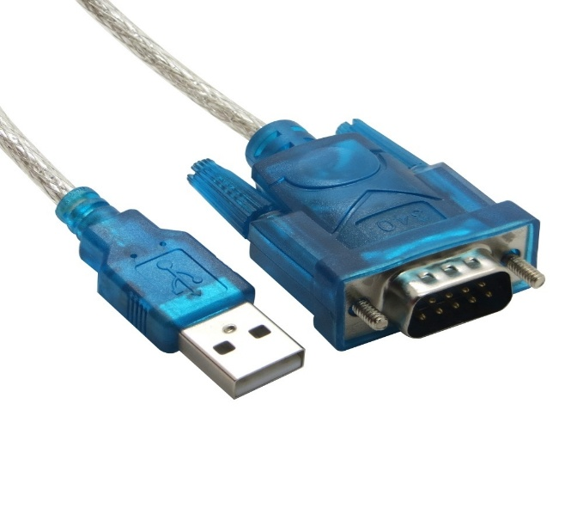
- Launch the Simulator Software. 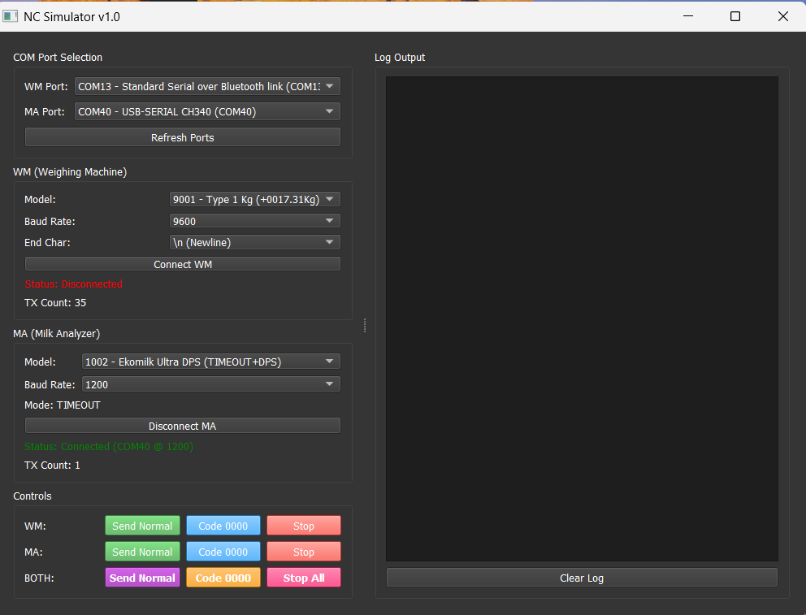
- In the simulator, select the MA port from the dropdown list.
  - If the port is not visible, open Device Manager, click Refresh Ports, and then select the correct port.
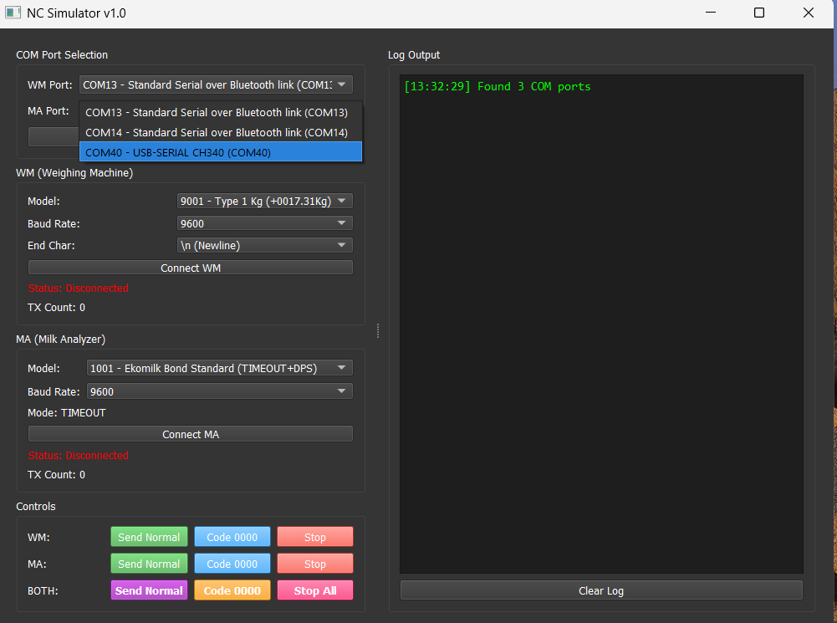
- Select the model and baud rate.
Note: The model and baud rate must match the configuration sent from the mobile app via BLE.
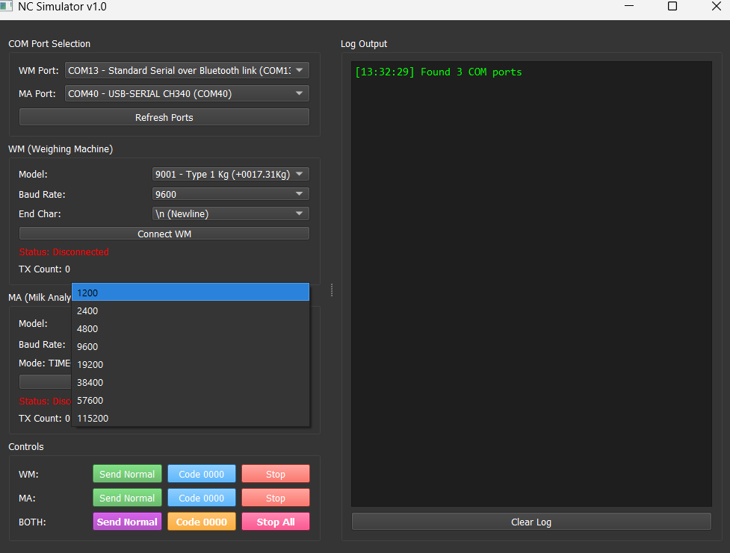
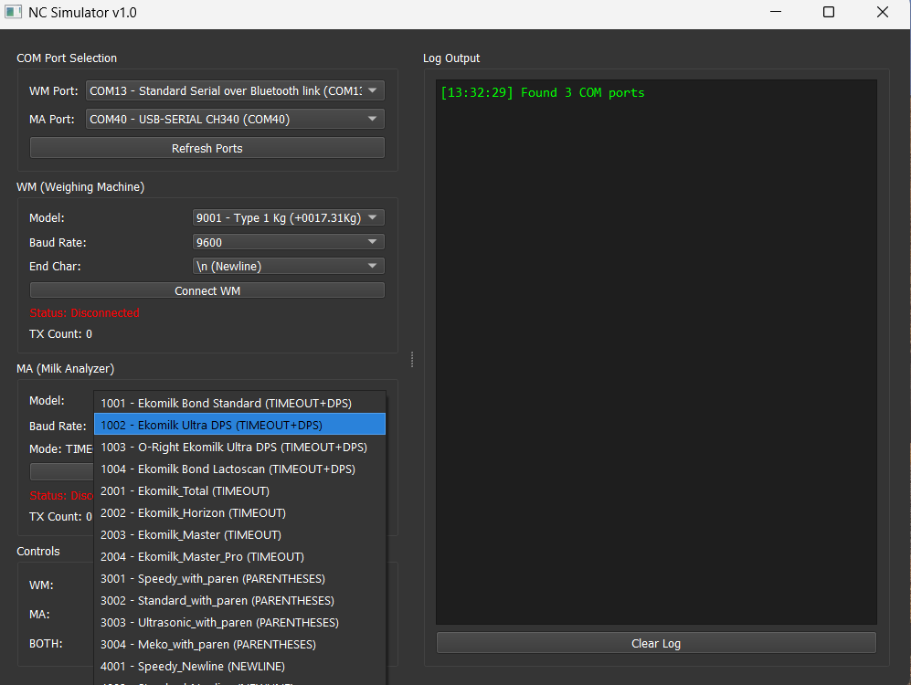
- Click on Connect MA, you will get the connected and port on the log.
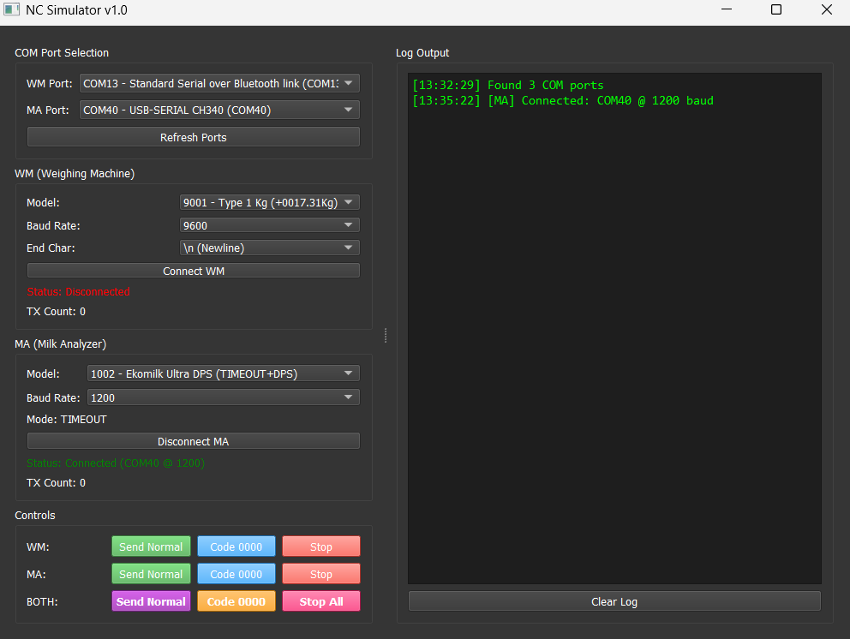
- Go to the Controls tab. In the Both field, click Send Normal.
- After approximately 5 seconds, click the Stop All button.
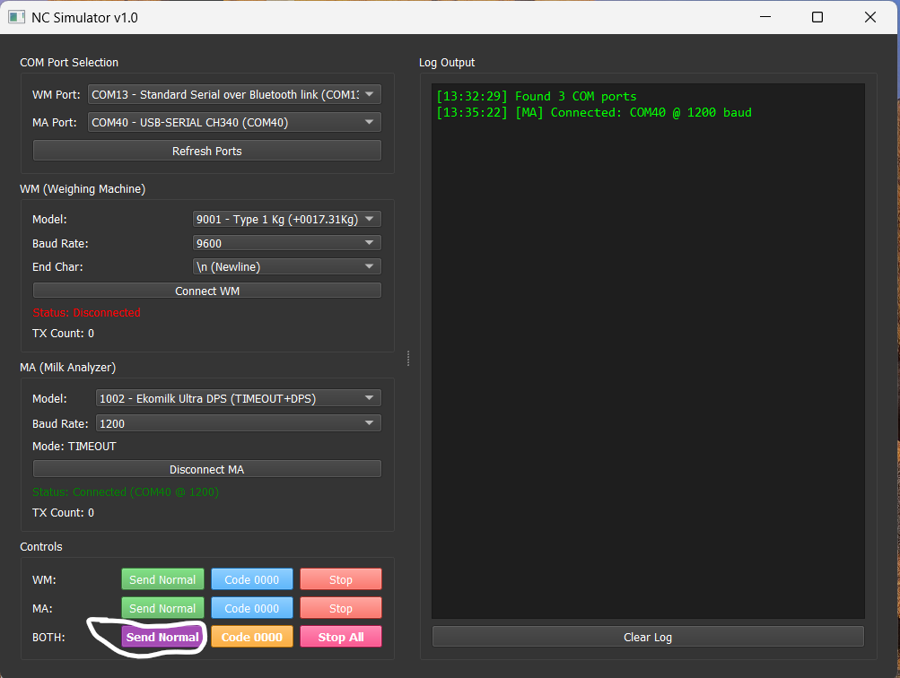

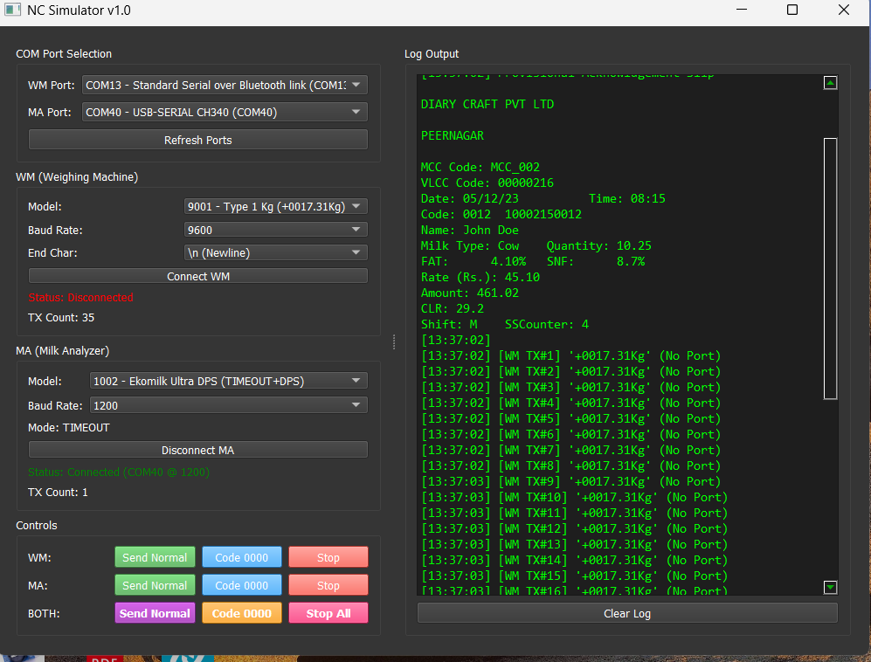
- The simulated MA data should be received and displayed on the mobile app (BLE Serial Monitor).

